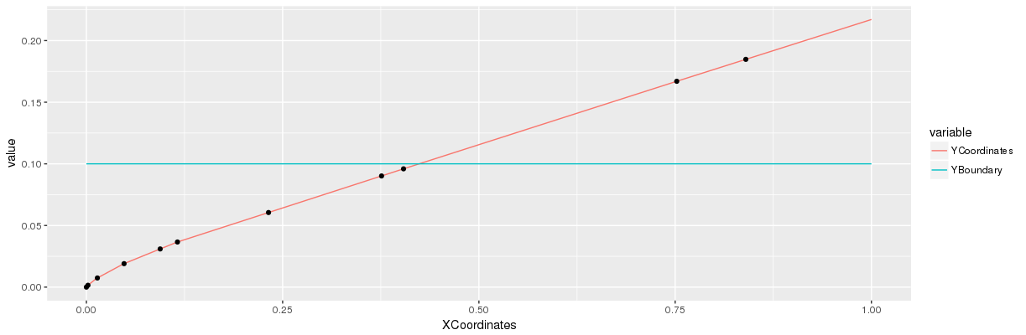

Cost=1
Lambda=0.1

quadratic 3/3.7^3 * x

[[1]]
[,1] [,2] [,3] [,4]
[1,] 0 0 0 0
[2,] 0 0 0 0
[3,] 0 0 0 0
[4,] 0 0 0 0
[5,] 0 0 0 0

[[2]]
[,1] [,2] [,3] [,4]
[1,] 1 0 0 0
[2,] 0 0 0 0
[3,] 0 0 0 0
[4,] 0 0 0 0
[5,] 0 0 0 0

[[3]]
[,1] [,2] [,3] [,4]
[1,] 2 0 0 0
[2,] 1 0 0 0
[3,] 0 0 0 0
[4,] 0 0 0 0
[5,] 0 0 0 0

[[4]]
[,1] [,2] [,3] [,4]
[1,] 3 0 0 0
[2,] 2 0 0 0
[3,] 1 0 0 0
[4,] 0 0 0 0
[5,] 0 0 0 0

[[5]]
[,1] [,2] [,3] [,4]
[1,] 3 1 0 0
[2,] 2 0 0 0
[3,] 1 0 0 0
[4,] 0 0 0 0
[5,] 0 0 0 0

[[6]]
[,1] [,2] [,3] [,4]
[1,] 4 1 0 0
[2,] 3 0 0 0
[3,] 2 0 0 0
[4,] 1 0 0 0
[5,] 0 0 0 0

[[7]]
[,1] [,2] [,3] [,4]
[1,] 4 1 1 0
[2,] 3 0 0 0
[3,] 2 0 0 0
[4,] 1 0 0 0
[5,] 0 0 0 0

[[8]]
[,1] [,2] [,3] [,4]
[1,] 4 1 1 1
[2,] 3 0 0 0
[3,] 2 0 0 0
[4,] 1 0 0 0
[5,] 0 0 0 0

[[9]]
[,1] [,2] [,3] [,4]
[1,] 4 2 1 1
[2,] 3 1 0 0
[3,] 2 0 0 0
[4,] 1 0 0 0
[5,] 0 0 0 0

[[10]]
[,1] [,2] [,3] [,4]
[1,] 4 3 1 1
[2,] 3 2 0 0
[3,] 2 1 0 0
[4,] 1 0 0 0
[5,] 0 0 0 0

[[11]]
[,1] [,2] [,3] [,4]
[1,] 4 3 2 1
[2,] 3 2 1 0
[3,] 2 1 0 0
[4,] 1 0 0 0
[5,] 0 0 0 0

